**Materials and Properties**

Before selecting certain material we should consider its properties like:-

* Strength
* Stiffness
* Density
* Ductility
* Fatigue resistance
* Cost of material
* Cost of machining and working

Properties depends on purpose of which the machine is intended.

Different types of materials used in the modern era

* **Steel**

Steel, either as tube or sheet, depending on design. There are several reasons for its choice

* Raw material cost is relatively low
* Well-developed manipulating and joining techniques are available
* Young’s modulus is high, so the requested stiffness can be obtained with small tube sizes

Steels have competitive advantages over light weight alloys and composites not only with regard to material cost, but also with respect to manufacturing cost.

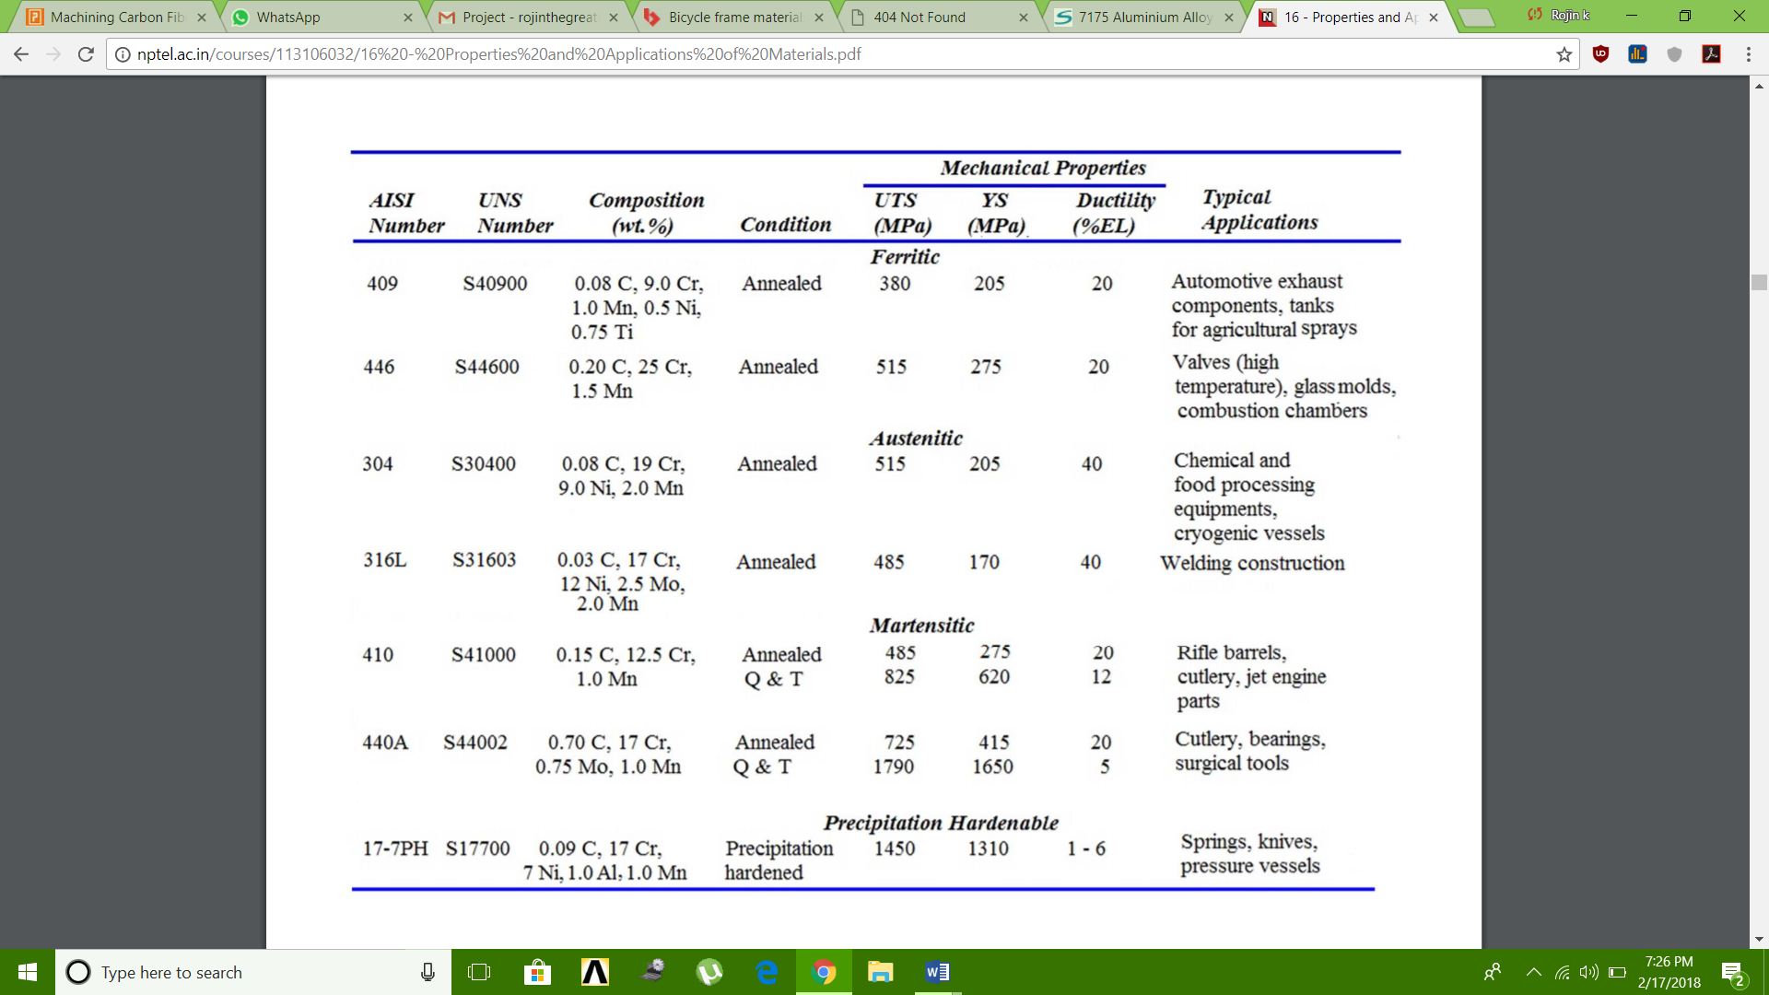

* **Aluminum**

**Aluminium is lighter than steel, durable enough for its structural purpose, very workable and above all, affordable.**

One of the best known properties of aluminum is that it is light, with a density one third that of steel, 2,700 kg/m3. The low density of aluminum accounts for it being lightweight but this does not affect its strength.

**Strength**

Aluminum alloys commonly have tensile strengths of between 70 and 700 MPa. The range for alloys used in extrusion is 150 – 300 MPa. Unlike most steel grades, aluminum does not become brittle at low temperatures. Instead, its strength increases. At high temperatures, aluminum’s strength decreases.

**Formability**

Aluminum’s superior malleability is essential for extrusion. With the metal either hot or cold, this property is also exploited in the rolling of strips and foils, as well as in bending and other forming operations.

**Joining**

Features facilitating easy jointing are often incorporated into profile design. Fusion welding, Friction Stir Welding, bonding and taping are also used for joining.

**Corrosion resistance**

Anodizing increases the thickness of the oxide layer and thus improves the strength of the natural corrosion protection. Where aluminum is used outdoors, thicknesses of between 15 and 25 mm (depending on wear and risk of corrosion) are common.

Aluminum is extremely durable in neutral and slightly acid environments.  
In environments characterized by high acidity or high basicity, corrosion is rapid.

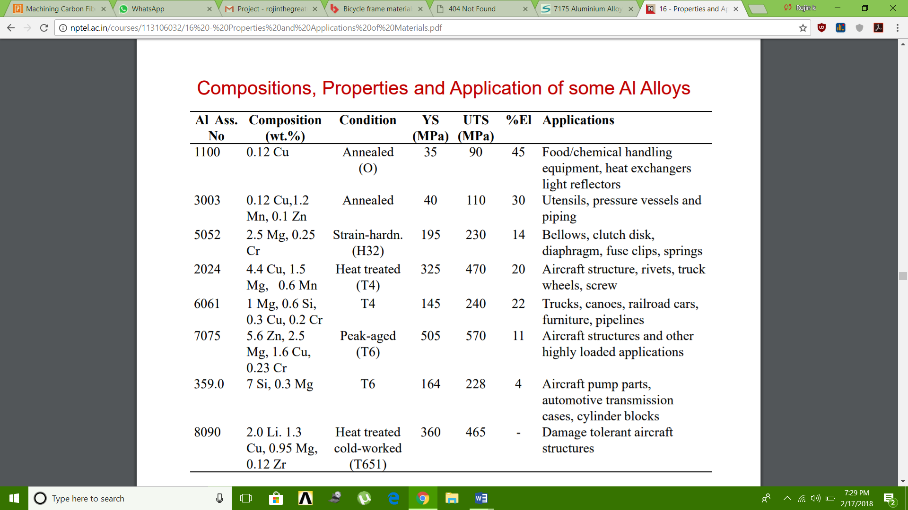

* **Carbon fiber**

Carbon fibers have several advantages including high stiffness, high tensile strength, low weight, high chemical

Resistance, high temperature tolerance and low thermal expansion

Its creation starts with eight lengths of ‘pultruded’ carbon-fiber.

Pultrusion is a method of making long tubes or strips out of carbon-fiber, where the woven or braided fibres are pulled through a bath of resin and then a heated die which cures the resin and forms the shape of the tubing, which can then be cut to the desired length.

Property of PEEK 450CA40 Polyetheretherketone, 40% Carbon Fibre Reinforced

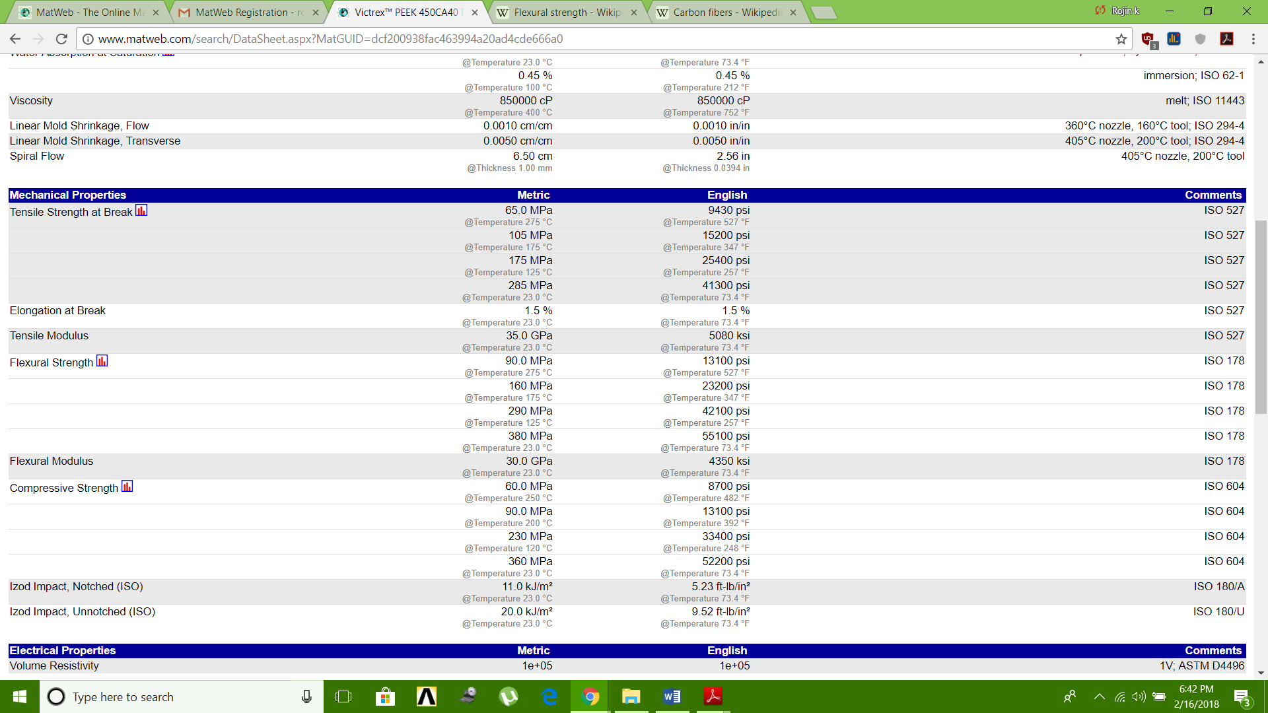

* **Magnesium**

Magnesium can be used to engineer bike frames that [are lighter than aluminum](https://mmta.co.uk/2016/06/01/materials-selection-in-bicycles/) while maintaining high tensile strength and damping capabilities. All of that leads to a much smoother, more efficient ride. Magnesium also comes in at a lower price point than popular lightweight materials like carbon fiber.

Property chart of magnesium

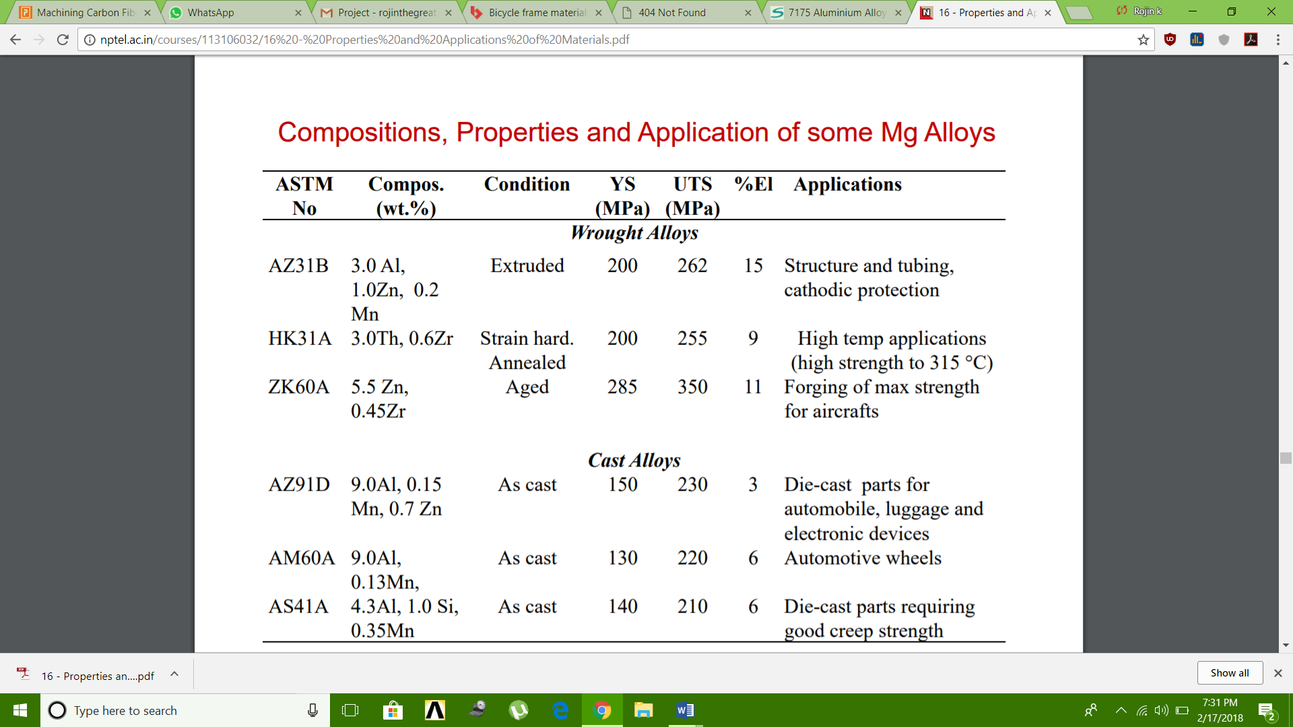

* **Titanium**
* As a [metal](https://en.wikipedia.org/wiki/Metal), titanium is recognized for its high [strength-to-weight ratio](https://en.wikipedia.org/wiki/Strength-to-weight_ratio).
* It is a strong metal with low [density](https://en.wikipedia.org/wiki/Density) that is quite [ductile](https://en.wikipedia.org/wiki/Ductility).
* Commercially pure (99.2% pure) [grades](https://en.wikipedia.org/wiki/Titanium_alloy#Grades_of_titanium) of titanium have [ultimate tensile strength](https://en.wikipedia.org/wiki/Ultimate_tensile_strength) of about 434 [MPa](https://en.wikipedia.org/wiki/Megapascal) (63,000 [psi](https://en.wikipedia.org/wiki/Pounds_per_square_inch)), equal to that of common, low-grade steel alloys, but are less dense.
* Titanium is 60% denser than aluminum, but more than twice as strong as the most commonly used [6061-T6 aluminum alloy](https://en.wikipedia.org/wiki/6061_aluminium_alloy). Certain titanium alloys (e.g., [Beta C](https://en.wikipedia.org/wiki/Titanium_Beta_C)) achieve tensile strengths of over 1,400 MPa (20, 0000 psi).
* Titanium is not as hard as some grades of heat-treated steel;
* Like steel structures, those made from titanium have a [fatigue limit](https://en.wikipedia.org/wiki/Fatigue_limit) that guarantees longevity in some

Applications.

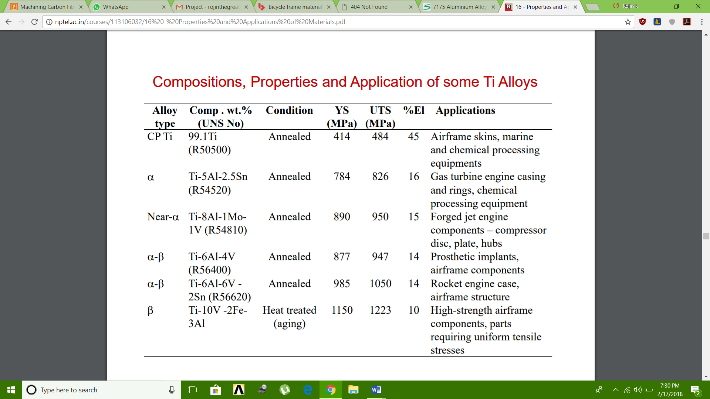

Cost of different materials per KG

1. **Steel**

Cromoly 4130 150/kg for pipes

1. **Aluminum**

|  |  |  |
| --- | --- | --- |
| 6061 T6 | 200 | per kilogram |
|  |  |  |

1. **Titanium**

Grade TI-6-4 BAR

CURRENT PRICE: 3540/kg

1. **Magnesium**

Magnesium AZ91D T6

Current Price: 3000/kg

1. **Carbon fiber**

Machinability of different materials

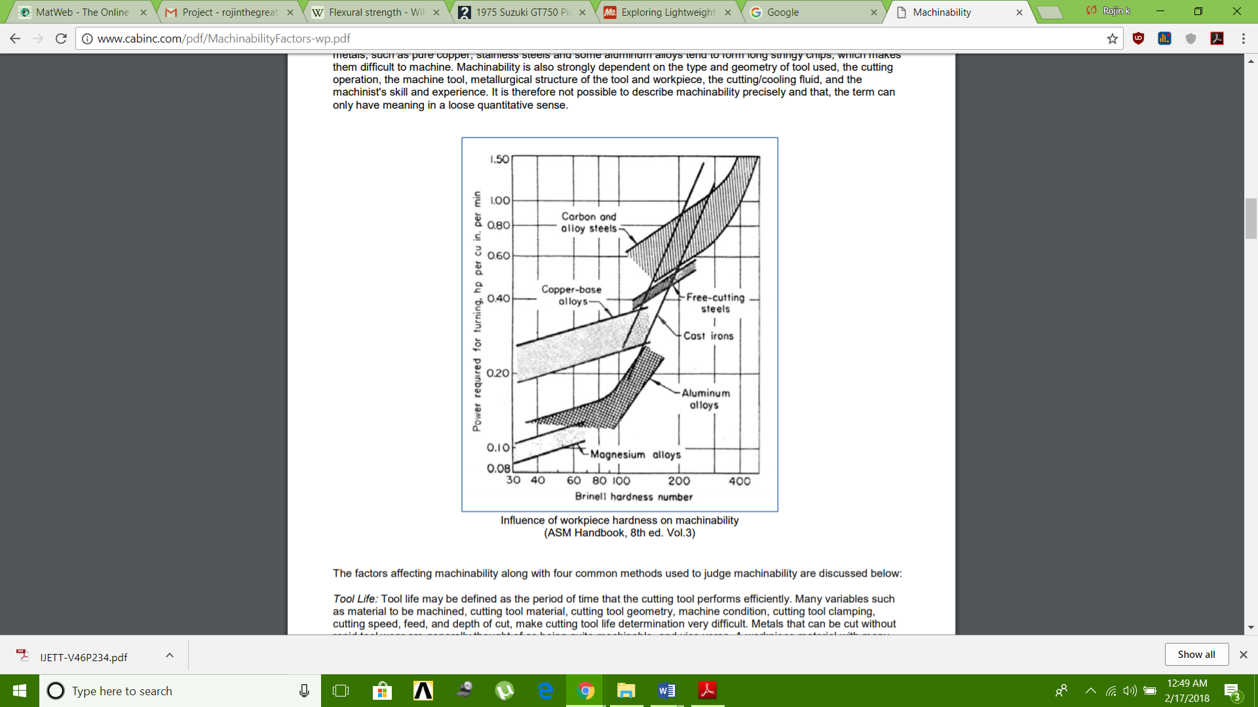

1. Steel

Machinability of medium carbon steels depends to a large extent on their microstructure. They machine best when they have the coarse pearlite or spheroidized carbide structure. Steels with carbon content in excess of 0.6% machine best in the fully spheroidized condition. As a general rule, tool wear rates increase in a consistent manner as the carbon content of work material is increased beyond 0.35%.

In general, surface finish improves with increasing carbon content up to 0.35%, however, the surface finish depends not only on carbon content but also on the cutting operation, the tool geometry and the cutting conditions.

1. Aluminum

Aluminum is easily worked using most machining methods – milling, drilling, cutting, punching, bending, etc. Furthermore, the energy input during machining is low.

Aluminum is very easy to machine, although the softer grades tend to form edge build-up resulting in poor surface finish. Thus, high cutting speeds, high rake angles, and high relief angles are recommended. Wrought aluminum alloys with high silicon content and cast aluminum alloys are abrasive; hence, they require harder tool materials. Controlling dimensional tolerances may be a problem in machining of aluminum because it has a high thermal expansion coefficient and a relatively low elastic modulus.

1. Titanium

Titanium and its alloys have very poor thermal conductivity (the lowest of all metals), causing a significant temperature rise and built-up edge. They are highly reactive and can be difficult to machine.

1. Magnesium

Magnesium is the lightest structural metal and exhibits excellent machinability. Some of the advantages of machining magnesium compared to other commonly used metals include: • Low power required – approximately 55% of that required for Al.

• Fast machining – employing the use of high cutting speeds, large feed rates and greater depths of cut

. • Excellent surface finish – extremely fine & smooth surface achieved.

• Well broken chips – due to the free-cutting qualities of magnesium.

• Reduced tool wear – leading to increased tool life.

To fully exploit and enjoy the advantages of machining magnesium, it is important that the unique characteristics of the metal are understood.

Material Selection

1. **Aluminum Alloy 6061 t4**

T4 temper 6061 has an [ultimate tensile strength](https://en.wikipedia.org/wiki/Ultimate_tensile_strength) of at least 210 MPa (30,000 psi) and yield strength of at least 110 MPa (16,000 psi). It has elongation of 16%.

Material Composition

|  |  |  |  |  |  |  |  |  |  |  |  |  |  |  |  |  |  |  |  |  |  |  |  |  |  |  |  |  |  |  |  |  |  |  |  |  |  |  |  |  |  |  |  |  |  |  |  |  |  |  |  |  |  |
| --- | --- | --- | --- | --- | --- | --- | --- | --- | --- | --- | --- | --- | --- | --- | --- | --- | --- | --- | --- | --- | --- | --- | --- | --- | --- | --- | --- | --- | --- | --- | --- | --- | --- | --- | --- | --- | --- | --- | --- | --- | --- | --- | --- | --- | --- | --- | --- | --- | --- | --- | --- | --- | --- |
| |  |  |  | | --- | --- | --- | | **Component** | **Wt. %** | http://asm.matweb.com/images/spacer.gif | | |  | | --- | | http://asm.matweb.com/images/spacer.gif | | | | Al | 95.8 - 98.6 |  | | Cr | 0.04 - 0.35 |  | | Cu | 0.15 - 0.4 |  | | Fe | Max 0.7 |  | | |  |  |  | | --- | --- | --- | | **Component** | **Wt. %** | http://asm.matweb.com/images/spacer.gif | | |  | | --- | | http://asm.matweb.com/images/spacer.gif | | | | Mg | 0.8 - 1.2 |  | | Mn | Max 0.15 |  | | Other, each | Max 0.05 |  | | Other, total | Max 0.15 |  | | |  |  |  | | --- | --- | --- | | **Component** | **Wt. %** | http://asm.matweb.com/images/spacer.gif | | |  | | --- | | http://asm.matweb.com/images/spacer.gif | | | | Si | 0.4 - 0.8 |  | | Ti | Max 0.15 |  | | Zn | Max 0.25 |  | |

Material properties

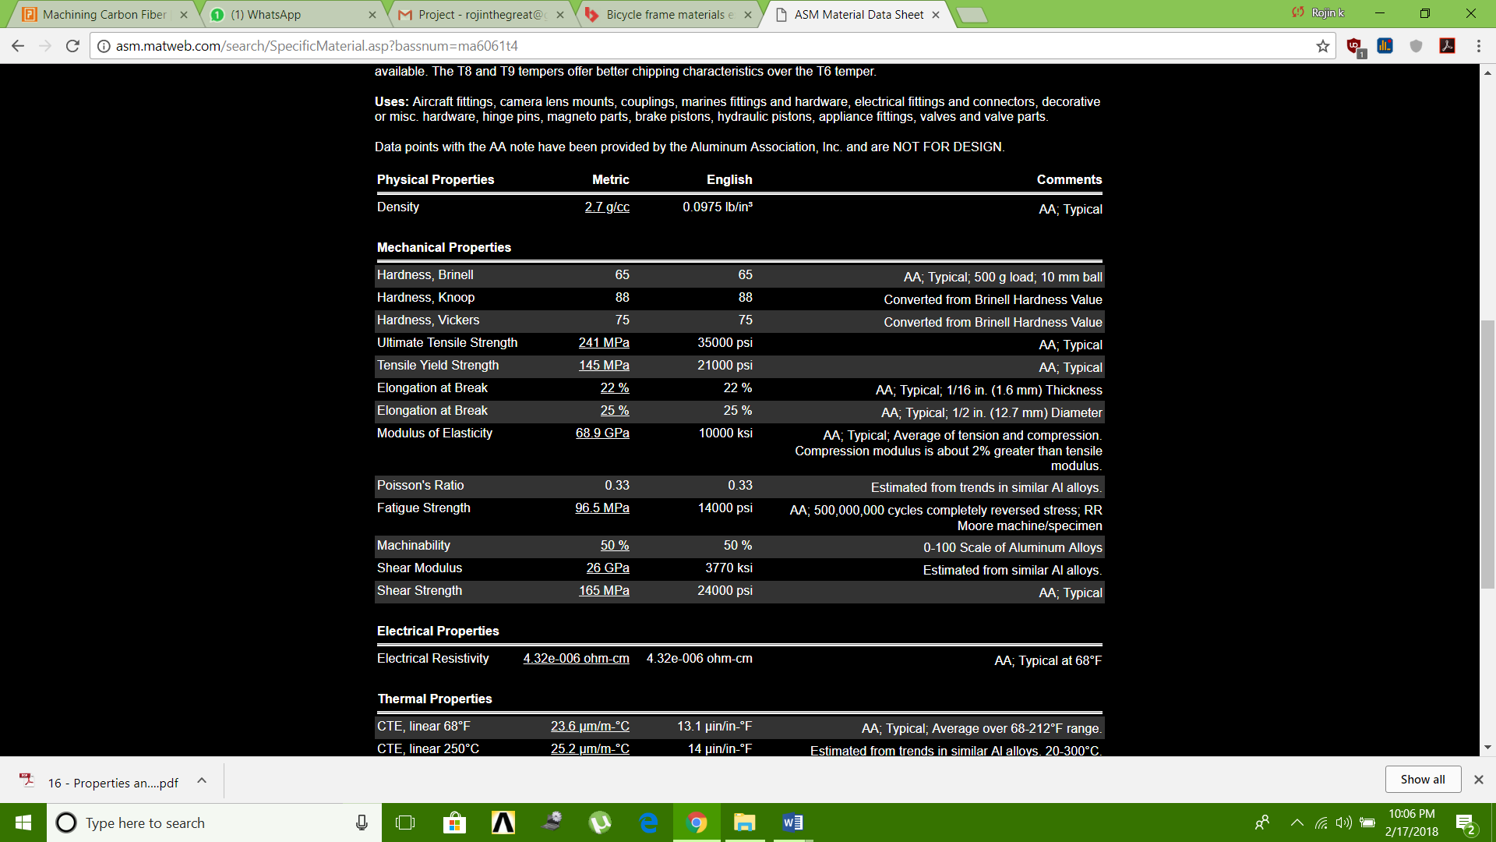

1. **Aluminum Alloy 6061 t6**

T6 temper 6061 has an ultimate tensile strength of at least 290 MPa (42,000 psi) and yield strength of at least 240 MPa (35,000 psi).

Material Composition

|  |  |  |  |  |  |  |  |  |  |  |  |  |  |  |  |  |  |  |  |  |  |  |  |  |  |  |  |  |  |  |  |  |  |  |  |  |  |  |  |  |  |  |  |  |  |  |  |  |  |  |  |  |  |
| --- | --- | --- | --- | --- | --- | --- | --- | --- | --- | --- | --- | --- | --- | --- | --- | --- | --- | --- | --- | --- | --- | --- | --- | --- | --- | --- | --- | --- | --- | --- | --- | --- | --- | --- | --- | --- | --- | --- | --- | --- | --- | --- | --- | --- | --- | --- | --- | --- | --- | --- | --- | --- | --- |
| |  |  |  | | --- | --- | --- | | **Component** | **Wt. %** | http://asm.matweb.com/images/spacer.gif | | |  | | --- | | http://asm.matweb.com/images/spacer.gif | | | | Al | 95.8 - 98.6 |  | | Cr | 0.04 - 0.35 |  | | Cu | 0.15 - 0.4 |  | | Fe | Max 0.7 |  | | |  |  |  | | --- | --- | --- | | **Component** | **Wt. %** | http://asm.matweb.com/images/spacer.gif | | |  | | --- | | http://asm.matweb.com/images/spacer.gif | | | | Mg | 0.8 - 1.2 |  | | Mn | Max 0.15 |  | | Other, each | Max 0.05 |  | | Other, total | Max 0.15 |  | | |  |  |  | | --- | --- | --- | | **Component** | **Wt. %** | http://asm.matweb.com/images/spacer.gif | | |  | | --- | | http://asm.matweb.com/images/spacer.gif | | | | Si | 0.4 - 0.8 |  | | Ti | Max 0.15 |  | | Zn | Max 0.25 |  | |

**Material Properties**

|  |  |  |  |
| --- | --- | --- | --- |
| **Physical Properties** | **Metric** | **English** | **Comments** |
| |  | | --- | | http://asm.matweb.com/images/spacer.gif | | | | |
| Density | [2.7 g/cc](http://asm.matweb.com/search/GetUnits.asp?convertfrom=43&value=2.7) | 0.0975 lb/in³ | AA; Typical |
| **Mechanical Properties** | | | |
| |  | | --- | | http://asm.matweb.com/images/spacer.gif | | | | |
| Hardness, Brinell | 95 | 95 | AA; Typical; 500 g load; 10 mm ball |
| Hardness, Knoop | 120 | 120 | Converted from Brinell Hardness Value |
| Hardness, Rockwell A | 40 | 40 | Converted from Brinell Hardness Value |
| Hardness, Rockwell B | 60 | 60 | Converted from Brinell Hardness Value |
| Hardness, Vickers | 107 | 107 | Converted from Brinell Hardness Value |
| Ultimate Tensile Strength | [310 MPa](http://asm.matweb.com/search/GetUnits.asp?convertfrom=79&value=45) | 45000 psi | AA; Typical |
| Tensile Yield Strength | [276 MPa](http://asm.matweb.com/search/GetUnits.asp?convertfrom=79&value=40) | 40000 psi | AA; Typical |
| Elongation at Break | [12 %](http://asm.matweb.com/search/GetUnits.asp?convertfrom=138&value=12) | 12 % | AA; Typical; 1/16 in. (1.6 mm) Thickness |
| Elongation at Break | [17 %](http://asm.matweb.com/search/GetUnits.asp?convertfrom=138&value=17) | 17 % | AA; Typical; 1/2 in. (12.7 mm) Diameter |
| Modulus of Elasticity | [68.9 GPa](http://asm.matweb.com/search/GetUnits.asp?convertfrom=79&value=10000) | 10000 ksi | AA; Typical; Average of tension and compression. Compression modulus is about 2% greater than tensile modulus. |
| Notched Tensile Strength | [324 MPa](http://asm.matweb.com/search/GetUnits.asp?convertfrom=109&value=324) | 47000 psi | 2.5 cm width x 0.16 cm thick side-notched specimen, Kt = 17. |
| Ultimate Bearing Strength | [607 MPa](http://asm.matweb.com/search/GetUnits.asp?convertfrom=109&value=607) | 88000 psi | Edge distance/pin diameter = 2.0 |
| Bearing Yield Strength | [386 MPa](http://asm.matweb.com/search/GetUnits.asp?convertfrom=109&value=386) | 56000 psi | Edge distance/pin diameter = 2.0 |
| Poisson's Ratio | 0.33 | 0.33 | Estimated from trends in similar Al alloys. |
| Fatigue Strength | [96.5 MPa](http://asm.matweb.com/search/GetUnits.asp?convertfrom=124&value=14000) | 14000 psi | AA; 500,000,000 cycles completely reversed stress; RR Moore machine/specimen |
| Fracture Toughness | [29 MPa-m½](http://asm.matweb.com/search/GetUnits.asp?convertfrom=111&value=29) | 26.4 ksi-in½ | KIC; TL orientation. |
| Machinability | [50 %](http://asm.matweb.com/search/GetUnits.asp?convertfrom=138&value=50) | 50 % | 0-100 Scale of Aluminum Alloys |
| Shear Modulus | [26 GPa](http://asm.matweb.com/search/GetUnits.asp?convertfrom=45&value=26) | 3770 ksi | Estimated from similar Al alloys. |
| Shear Strength | [207 MPa](http://asm.matweb.com/search/GetUnits.asp?convertfrom=79&value=30) | 30000 psi | AA; Typical |
|  |  |  |  |

Fatigue Behavior of aluminium 6061 T6

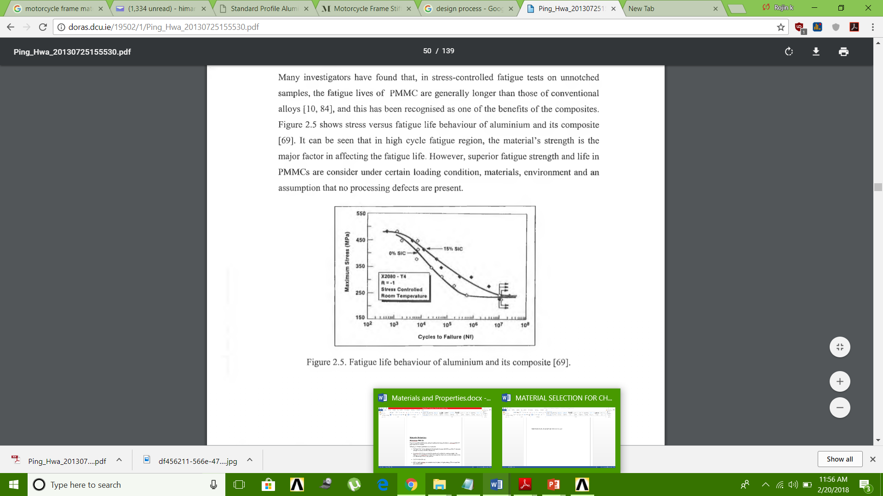

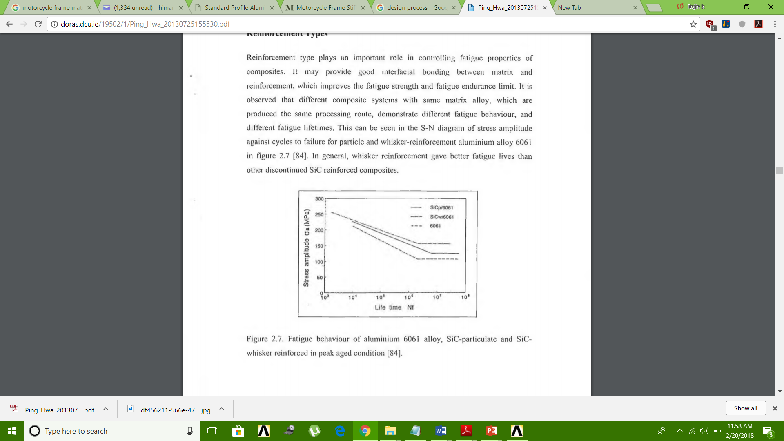

**Material Selection**

**Aluminium 6061 t6**

From the properties obtained from different materials the finalized material is aluminium 6061 t6 grade metal for the chassis.

Following are the key properties for the finalization:

* T6 temper 6061 has an ultimate tensile strength of at least 290 MPa (42,000 psi) and yield strength of at least 240 MPa (35,000 psi).
* Aluminium 6061 t6 has one-third the density and one-third the modulus of steel – the diameter of the aluminium bar needs to be larger by 32 per cent, at which its weight will be only 58 per cent of that of the steel bar.
* Cost is comparably low.
* 6061 is highly weldable, for example using [tungsten inert gas welding](https://en.wikipedia.org/wiki/Tungsten_inert_gas_welding) (TIG) or [metal inert gas welding](https://en.wikipedia.org/wiki/Metal_inert_gas_welding) (MIG).
* 6061 has good fatigue behavior with fatigue strength of 125 mpa.